Vanquis Bank
Project description – Vanquis . I have delivered 3 impactful projects during my 7 years of tenure .
- Entity hub – 2016 feb to 2018
In this project at Vanquis Bank, I worked on building a centralized customer data platform called the Entity Hub. The goal was to create a single source of truth for customer data.
I developed a proxy web service using the Ab Initio Web Service Framework, which acted as a layer between front-end applications and backend systems. This helped to standardize how customer data was accessed and ensured data consistency.
Additionally, I extended the Flow Bus to support the new mobile app backend. One of the key improvements was implementing secure tokenization, so sensitive details like account, customer, and card numbers were not exposed, except during the KYC journey.

“How did tokenization work?”
Answer:
“In our solution, we replaced sensitive customer identifiers—like account number, card number, and customer ID—with a generated secure token.
When a request came into the proxy service, the actual sensitive data was mapped to a token using a backend mapping store. Downstream systems only saw the token, not the real values. Only during the KYC journey, where it was strictly required, we resolved the token back to the original data.
This approach ensured that sensitive data was not exposed across multiple systems, reducing security risk and helping with compliance requirements.”

“How did you ensure data consistency?”
Answer:
“We ensured data consistency by creating the Entity Hub as a single source of truth for customer data.
All upstream systems fed into this hub, and downstream systems accessed data through the proxy service rather than directly from source systems.
We implemented validation rules and business logic in the Ab Initio layer to standardize and cleanse incoming data. In addition, we used controlled update mechanisms to ensure that changes were propagated consistently across systems.
This approach reduced duplication, avoided conflicting data, and ensured all channels—especially the mobile app—worked with the same, consistent customer information.”

- Fico – Vcap Integration 2018 -2021
Project Objective
- The objective of this project was to integrate a new Credit Card Application system with the bank’s internal analytical platform in a scalable and near-real-time way.
- We built a data pipeline to bring credit card application data from the FICO system into the in-house Hadoop-based analytical platform using the Hortonworks ecosystem. The data was then structured and modelled to support the bank’s Applicant Affordability Scorecard.

Architecture Overview
- The source application was publishing loan application events into Azure Service Bus. Since NiFi could not directly consume Service Bus messages due to a tooling limitation at that time, we designed an intermediate integration layer.
- The architecture worked like this:
- An Azure function / Java Azure app read messages from Azure Service Bus
- It stored the header/metadata in Azure Storage Queue
- It stored the full payload in Azure Blob Storage
- The payloads were in XML and JSON, so they were semi-structured
- A generic NiFi framework consumed the header messages from the queue
- NiFi then used those headers as pointers to fetch the actual payloads from Blob Storage
- NiFi parsed and shredded the XML/JSON into structured datasets
- The structured output was written into HDFS on the Hortonworks platform
- The data was then exposed through Hive for analytics and also made available to on-prem SQL Server consumers
- Later, we improved this design by writing the processed data in ORC format to ADLS Gen2 instead of HDFS.

What “shredding” means in this project
- The incoming XML and JSON files had nested and hierarchical data.
NiFi transformed them into structured, query-friendly datasets by:
- parsing nested XML/JSON
- extracting important fields
- flattening repeating sections
- separating parent-child elements
- converting semi-structured payloads into tabular data
- For example, a credit application payload could contain:
- applicant details
- address history
- employment data
- affordability attributes
- decision metadata
- Instead of storing the raw file only, we converted it into structured data that could be queried and used for scorecard modelling.

Why this architecture was good at the time
- This was a strong architecture for that stage because:
- it was event-driven, so it was closer to near-real-time than batch-only processing
- it decoupled source and target systems
- it separated message metadata from the actual payload
- it allowed NiFi to work around its Service Bus limitation
- it created a generic reusable ingestion framework, not a one-off pipeline
- it handled semi-structured XML/JSON ingestion effectively
- it connected Azure-native services with the bank’s Hadoop/Hive ecosystem and on-prem SQL Server

Limitations / Cons of the architecture
- Although it worked well, it had some drawbacks:
- the architecture had multiple moving parts, which increased operational complexity
- configuration complexity
- HDFS on Hortonworks had higher infrastructure and support overhead
- storage and compute were more tightly coupled in the Hadoop model
- supporting and scaling the platform over time became more expensive
So while the architecture was practical and robust at the time, it was not the most cost-efficient or future-ready model in the long term.
How we improved it later
- We later improved the solution by writing the processed data in ORC format to ADLS Gen2 instead of HDFS.
- This gave several benefits:
- lower cost, because ADLS Gen2 reduced the dependency on HDFS-based infrastructure
- better query performance, because ORC is a compressed columnar format
- reduced storage footprint
- better separation of storage and compute
- easier future integration with modern platforms like Databricks, Spark, and Synapse
- So the later design moved the solution closer to a more modern cloud-native data lake architecture.

- The objective of the project was to integrate a new Credit Card Application system with the bank’s analytical platform in a scalable, near-real-time way, so that we could use the data for applicant affordability scorecards.
- The source system published loan application events into Azure Service Bus, but NiFi could not directly consume those messages at that time, so we built an intermediate Azure-based integration layer. That layer read the Service Bus messages, stored lightweight headers in Azure Queue, and stored the actual XML/JSON payloads in Blob Storage.
- We then built a generic NiFi framework that consumed the queue messages, used them as pointers to fetch the payloads from Blob, and shredded the semi-structured XML/JSON into structured datasets. Those outputs were written to HDFS on the Hortonworks platform and exposed through Hive and SQL Server for analytics and downstream use.
- The architecture worked well because it was event-driven, reusable, and good at handling semi-structured data while bridging Azure services with the existing Hadoop platform. The downside was that it had several moving parts and relied on HDFS, which increased operational cost and complexity.
- We later improved the design by storing the output as ORC files in ADLS Gen2 instead of HDFS. That reduced cost, improved query efficiency, and moved the solution toward a more modern cloud-native architecture.

- Single beaureau
The objective of this project was to build a robust lending decision data platform for Vanquis by centralising Credit Reference Agency data, especially from Experian, into a single analytical environment.
The business goal was to move away from multiple CRA sources and create a trusted bureau dataset that could support:
- lending decisions
- affordability and risk assessment

Architecture summary from the diagram
The architecture is a secure Azure-based ingestion and analytics pipeline with four main stages:

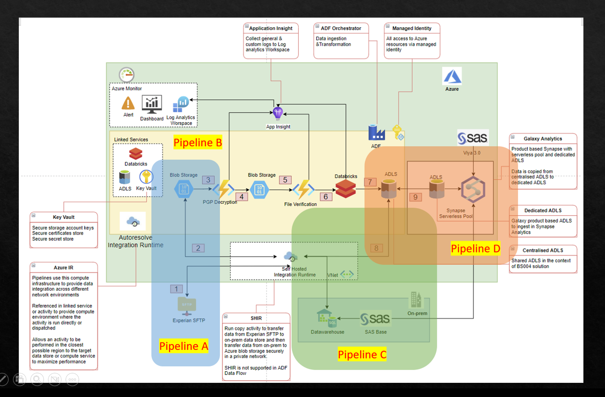

Galaxy Architecture – Pipeline Summary
Pipeline A – Experian SFTP to cloud landing storage
- Purpose: Securely pull raw Experian files from SFTP into the cloud landing area.
- Runs hourly using an ADF scheduled trigger.
- Checks which files are available on the Experian SFTP.
- Waits for a small delay before reading files, because Experian uploads files in stages and early pickup could lead to incomplete reads.
- Copies encrypted .pgp files into the cloud landing zone.
- Archives the files and then removes the originals from the SFTP location.
- In simple terms:
Pipeline A is the secure ingestion layer. It brings encrypted files from Experian into Azure safely and reliably.

Pipeline B – Landing storage to curated data lake
- Purpose: Decrypt, validate, organise, and process raw files into structured data in the data lake.
- Starts automatically whenever a new file arrives in the incoming folder.
- Decrypts the file into a temporary working area.
- Derives metadata such as year, month, and file type from the file.
- Moves the file into a structured folder hierarchy for processing.
- Uses an Azure Function to check whether all required file segments are present before processing.
- Places a logical lock on the file type folder to stop duplicate or concurrent processing of the same dataset.
- Triggers Databricks notebooks, with one notebook per file type, to process the files.
- Writes the output into ADLS under CreditBureau in Parquet format.
- Separates PII data and Base data.
- Moves the original decrypted files into archive.
- Raises a custom event once processing is complete.
- In simple terms:
Pipeline B is the main transformation layer. It takes encrypted raw bureau files, validates and processes them, and writes clean structured data into the lake.

Pipeline C – Data lake to on-prem data warehouse
- Purpose: Load the processed credit bureau data from the data lake into the on-premise warehouse for downstream business use.
- Starts when Pipeline B raises the load completed event.
- First checks whether the month has already been loaded.
- Validates that all required file types are present before continuing.
- Runs a Databricks notebook to combine multiple bureau datasets into a single formatted output.
- Applies required business transformations.
- Writes the consolidated result as CSV into the data lake.
- Deletes older records from the on-prem table based on a retention rule.
- Loads the new data into the on-prem database table.
- Logs row counts for monitoring and audit purposes.
- In simple terms:
Pipeline C is the integration layer to legacy/on-prem systems. It takes curated cloud data, combines and formats it, and pushes it into the on-prem data warehouse.

Pipeline D – Data lake to Synapse cloud analytics layer
- Purpose: Make the processed bureau data available for cloud analytics and reporting in Synapse.
- Triggered by the same load completed event from Pipeline B.
- Copies Parquet data from the main ADLS zone into the Synapse analytics storage area.
- Uses Synapse Serverless instead of a dedicated pool, because usage is occasional and this is more cost-efficient.
- Creates or refreshes views through stored procedures, with some views specific to particular file types.
- A second Synapse pipeline converts staged CSV outputs from Pipeline C into Parquet.
- Rebuilds the main Customer Management view used for analytics.
- In simple terms:
Pipeline D is the cloud analytics serving layer. It prepares the processed bureau data for Synapse-based reporting and analytical consumption.

Overall Architecture in one line
- Pipeline A ingests encrypted files from Experian.
- Pipeline B decrypts, validates, and transforms them into curated lake data.
- Pipeline C sends consolidated results to the on-prem warehouse.
- Pipeline D makes the same data available in Synapse for cloud analytics.

Canopius – Insight data platform

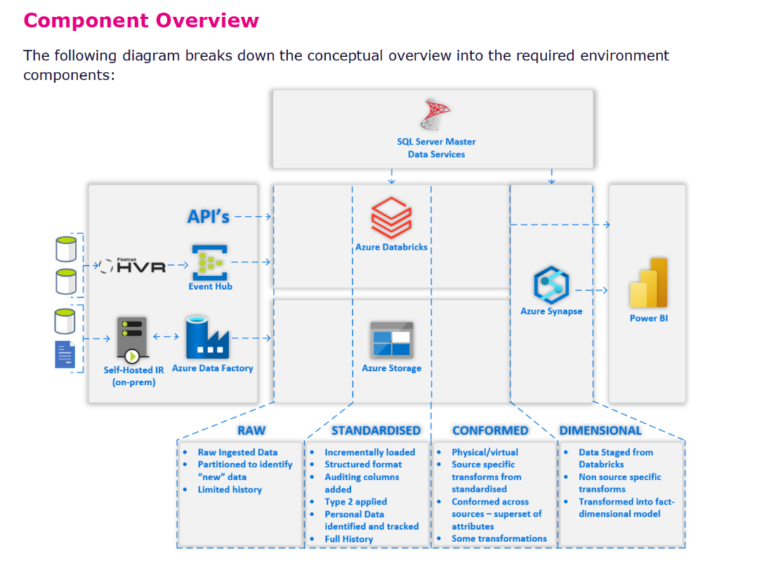
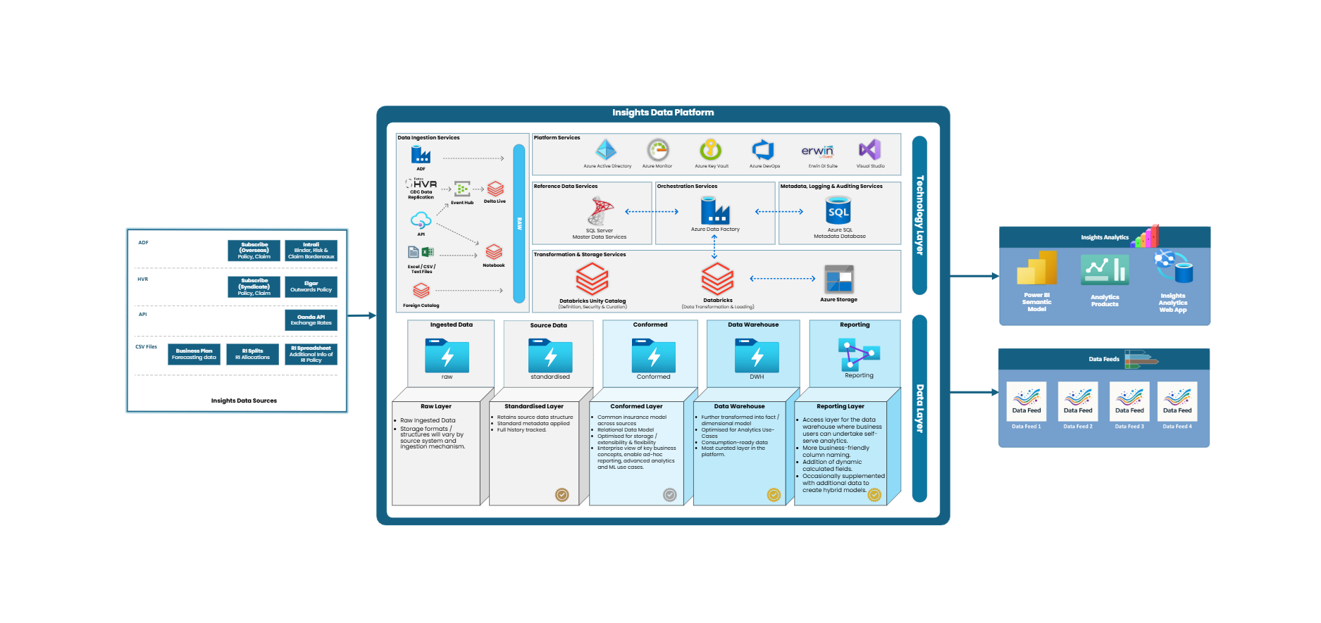
- The objective of the Insight Data Platform at Canopius was to build a unified cloud-native data platform on Azure using Databricks, bringing together multiple data sources into a single governed environment to support actuarial modelling, underwriting decisions, and regulatory reporting.
- Architecturally, the platform used CDC and Event Hub for change capture, ADF and Self-Hosted Integration Runtime for orchestration and hybrid ingestion, Azure Storage for the data lake zones, and Databricks as the main transformation engine. Data moved through Raw, Standardised, Conformed, and Dimensional layers before being served through Synapse and Power BI.
- My role involved architecture contribution, pipeline development, and end-to-end delivery. I also led the migration from Azure Synapse to a Databricks Lakehouse model, redesigned pipelines using PySpark and Delta Lake, and implemented Databricks Asset Bundles to standardise CI/CD and deployment. The result was a more scalable, secure, and high-performing platform.”

Canopius – Data Products
For the last one and a half years at Canopius, I’ve been leading a programme called Data Products. The goal was to migrate around 15 siloed legacy systems from a costly on-prem SQL Server warehouse into a single cloud-native platform, with the long-term aim of decommissioning the old warehouse.
My role was to lead the architecture execution, technical delivery, and stakeholder alignment for all of those data products. When I joined, the high-level direction was already clear: I decided instead of reconnecting to the original on-prem source systems, we would reuse the existing cloud-based Insight Platform and the already migrated data available there to build the products.
The interesting part was that the biggest challenges were not only technical. We had limited documentation, unclear data ownership, incomplete understanding of some legacy systems, unclear how downstream uses the data, So I approached it not just as a migration, but as both a platform transformation and a operating model change with stakeholders.
On the technical side, I introduced reusable frameworks, standardised delivery patterns, and embedded governance, observability, and quality controls into the platform foundation so the products would be scalable and supportable.
On the stakeholder engagement side – First my involvement was to identify the data owners. This phase took lot of time but once done it was a roller coaster ride. On the stakeholder side, I was heavily involved in organising meetings, prioritising requirements, running workshops and whiteboarding sessions, shaping the roadmap, and aligning both business and engineering teams throughout the programme.
Some of the products also had external consumers, so it was important that the platform was not only technically sound, but also reliable and governed for wider downstream use.

1) Main success story: Canopius Data Products Programme
How to tell the story
- “One of the projects I’m most proud of is a programme I’ve been leading at Canopius for the last one and a half years called Data Products.
- The objective was to migrate around 15 siloed legacy systems that were running on a costly on-prem SQL Server warehouse into a single cloud-native platform, with the long-term aim of decommissioning the old warehouse.
- When I joined, the strategic direction was already clear: instead of reconnecting back to the original on-prem source systems, we would reuse the existing cloud-based Insight Platform and the already migrated data available there as the foundation for building those products.
- What made the programme challenging was that the biggest bottlenecks were not only technical. We had limited documentation, unclear data ownership, incomplete understanding of some of the legacy systems, and overlap in downstream consumption. So the challenge was as much about operating model and stakeholder alignment as it was about architecture.
- My role was to lead the architecture execution, delivery, and stakeholder alignment across all of the products. I approached it as both a platform transformation and a delivery model change. I introduced reusable engineering frameworks, standardised delivery patterns, and embedded governance, observability, and data quality into the platform foundation so that teams were not building one-off solutions.
- I also spent a lot of time driving alignment — organising stakeholder meetings, running workshops and whiteboarding sessions, prioritising requirements, and helping teams understand which parts of the legacy behaviour needed to be preserved and which parts needed to be redesigned. Some of the products also had external consumers, so reliability and governance were especially important.
- The programme delivered strong results: we migrated 15-plus legacy applications into governed cloud-based data products, reduced processing time by around 60 to 70 percent, and enabled about 50 users to consume data from the cloud platform.
- What made it rewarding for me was that it was not just a migration. It was a chance to combine architecture, delivery leadership, and stakeholder management to create something scalable and genuinely useful to the business.”

Why this story is strong for Databricks
- This story shows your strengths in:
- large-scale platform transformation
- Databricks / cloud-native thinking
- stakeholder leadership
- delivery ownership
- governance and production readiness
- turning ambiguity into structure
- This is very relevant to Databricks because hiring managers often look for people who can not only design good architecture, but also help organisations adopt it successfully.

2) Backup success story: Vanquis VCAP Integration
- This one is good because it shows technical depth, learning agility, and architecture evolution.
How to tell the story
- “Another project I’m proud of was at Vanquis, where I worked on the VCAP integration and the wider data platform landscape supporting lending and affordability use cases.
- The business need was to bring credit application and affordability-related data into the bank’s internal analytical platform in a scalable and reliable way. At that point, the environment involved a mix of Hadoop ecosystem technologies such as NiFi, HDFS, Hive, YARN, and Ranger, along with Azure services like ADF, Service Bus, Functions, and storage.
- What made this challenging was that it sat at the intersection of integration, platform engineering, and business-critical decisioning. It was not just about moving data from A to B — the data had to be structured in a way that supported affordability scorecards and downstream lending analytics.
- One part I found especially rewarding was how much I had to learn and adapt. NiFi was relatively new to me at the time, so I invested heavily in self-learning, hands-on experimentation, and understanding how it behaved in real ingestion scenarios. Over time, I went from learning the tool to becoming one of the go-to people in the team for NiFi-related implementation and design questions.
- I also contributed to improving the architecture itself. Moving away from hdfs to adls saved loads of money , maintennence overhead . Also updated file format from avro / orc.
- For example, in one enhancement area, I explored whether some of the NiFi-led ingestion patterns could be simplified through a Databricks Structured Streaming style approach. That work helped shift the thinking from tool-by-tool integration to a more modern platform architecture mindset.
- For me, this project was rewarding because it developed both my technical depth and my platform thinking. It taught me how to learn quickly, become credible in new technologies, and then use that learning to influence architecture decisions rather than just execute tasks.”

3) How learning helped you
- This is an important angle, because Databricks likes people who are curious and adaptable.
- You can say:
- “A theme across both projects is learning agility. At Vanquis, I had to get up to speed very quickly on NiFi and the broader Hadoop ecosystem, and that pushed me to become much more hands-on and experimental in how I learn new tools. At Canopius, the learning was different — it was more about navigating ambiguity, understanding legacy business logic, and converting fragmented knowledge into scalable cloud products.
- So I’d say my learning style is one of my strengths: I learn quickly, but I also try to convert that learning into reusable patterns, better architecture decisions, and stronger team delivery.”

4) How your strengths are represented
- Here’s a clean way to frame that for the hiring manager:
Your strengths
- 1. Platform transformation leadership
You can lead a programme, not just an individual pipeline.
- 2. Architecture with delivery discipline
You do not stop at target-state diagrams. You bring architecture into implementable, governed delivery.
- 3. Stakeholder alignment
You can work across business, engineering, and external consumers.
- 4. Learning agility
You can quickly learn a new technology, go deep enough to become credible, and then use it to improve delivery.
- 5. Reusable thinking
You naturally move toward frameworks, standardisation, and long-term scalability rather than one-off fixes.

5) Strong closing line for hiring manager round
- You can end with something like:
- “If I had to summarise my strengths, I’d say I’m at my best when a programme is complex, slightly ambiguous, and needs both architecture leadership and delivery structure. That’s where I can add the most value — turning fragmented systems and requirements into scalable data products and platforms that people can actually trust and use.”

The Canopius Data Products programme probably represents me best, because it brought together the things I’m strongest at: platform transformation, architecture execution, delivery leadership, and stakeholder alignment. The Vanquis VCAP work is another strong example, especially of my technical depth and ability to learn quickly, because that was where I grew into new technologies like NiFi and broader platform integration patterns.

